
interaction design
Refuoehape Khasake: 1818169


module code: c8-ide-11 Lecturer: mr moeketsi masupha

Question 1
- Medi-clinical System
- Technique for data gathering:

Interviews:
- faster as feedback is acquired immediately.
- Accurate as both interviewer and interviewee can ask questions and get clarification on a matter immediately.
- Facial expression can be seen to emphasize the depth of a message.
Disadvantages of other data gathering methods:
Observation
- Time-consuming: as stated by www.applustopper.com, observation requires one to take a long-time watching end-user in the real environment, this means it takes long before getting required results.
- Expensive: it requires one to either go to the physical environment each time to observe end user’s and interact with them or rather use expensive tools like cameras.
- Typical requirements of the system:
Usability goals
- speed: the system should not load for long when sending patients information into the database.
- Error-tolerant: the system should not pop error messages when the end user (patient and nurse) tries to enter or view information.

User-experience goals
- Clear language: according to Wilson (2017) the system should be developed in a way that nurses and patients will understand. Any terminologies should be excluded so it becomes simpler.
- Informative feedback: the system should be developed in a way that the provided feedback is relevant to action taken by users, for example; a user who registered in the system should received a message showing that registration was successful.

Environmental goals:

Accessibility: the system shall be easily reached by patients without much effort as they are sick and cannot afford to walk long distances to check information like check-up dates.
- Climate conditions: the physical devices on which the app will be operated with not be affected by rain or wind as it will be done on a phone.
User characteristics
- Educational level: Golodov (2019) states that people should be able to understand what is required of their activities from the system and follow the steps easily despite their background knowledge of computers.
- Disability: patients with disabilities either visually or physically should have access to the system.

Data requirements
- Information should be stored securely in the database.
- Necessary information should be retrievable and used.

Functional requirements
- The system should allow easy input and storage of patient records.
- The system should allow to delete unnecessary information.
- The system should allow updating and viewing of information.
- The system will allow patients to set appointments and view appointments date
- The patients should search their medical information and prescriptions made by doctors.
- The nurses should view patient medical information and retrieve the files.

- Persona for Medi-clinical System
Name: Jane Wilson
Demographics:
- Age: 18-24
- Mother
- Education level: varsity student
Behaviours:
- Caring
- Loving
- Over-protective

Personal qualities
- Medi-clinical System would be a caring person who looks after the sick by bandaging wounds
- He ensures patients got medication on time
- He keeps check-up time tables for patients
Goals
- To monitor medical equipment.
- He draws up patients’ medical plan
Where to find
- Hospital
- Home
- Scenario of how nurses and patients interact with the system
It is bad times and covid-19 has changed everyone’s lives including access to medical services in the nearest clinics. The government has set rules and legislation which restrict people from going to clinics and interacting with each other. This means a patient needs to set appointment and view prescription via online service, so they can get access to clinic services. It is clear an alternative is needed, and the government concluded that a mobile/web application would be built to assist in making the current situation easier. The nurses need to adapt to new life style of using medi-clinical system, a mobile app which consists of login and registration link for patients and nurses. A display window shows selection of choice options. Nurses will be required to fill login form. By default, if the login credentials are valid they will be taken to the next page where more roles like checking and confirming patient appointments will be done, make prescription, admit or discharge patients. On the other hand the patients need to use the system as it is designed such that it allows them to login using the registered credentials, and the system will then take them to a page where they view prescription, set appointment, check nurse assigned, check treatment required and check health status.
- Use case diagram
Normal course
- Nurse, patient and doctor should register and login to the system.
- Patient should book an appointment on the system.
- Doctor and nurse should prescribe medication for patient.
- Patient should view prescribed medication.
- Doctor and nurse should search for patient records.
Alternative course
- If registration fails, a message should be displayed saying registration was unsuccessful, check all fields are entred.
- If login fails, an error message should be displayed saying the credentials do not match.
- If assigning a doctor fails, a message doctor is already booked for the day, choose another date should pop up.

Question 2
a)
Conceptual model
Interface type
- Touch screen graphical user interface: it can be zoomed for visually impaired people to see the images clearly and increase text size.
Interface metaphor
- According to Neal, D and Carroll, J (2022), interface metaphor helps the user create their own expectations about a system and make their own predictions of how it might behave based on the name given to it. Medi-clinical system is predicted to be a system that already checks sickness and tells severity as soon as one starts using it.

Interaction type
- Conversing: this is a way in which a user has conversation by inputting voice, so the system responds to the command made, for instance; applying voice recorder.
- Menu selection: this is a way of choosing an action to perform from a menu and having an option to navigate to another page.
Functions
- The system should allow easy input and storage of patient records.
- The system should allow to delete unnecessary information.
- The system should allow updating and viewing of information.
- The system will allow patients to set appointments and view appointments date
- The patients should search their medical information and prescriptions made by doctors.
- The nurses should view patient medical information and retrieve the files.
Activities
- Register details.
- Login with registered credentials.
- Search on the search bar.
- Prescribe medication.
- View prescription and registered records.

b) Storyboard
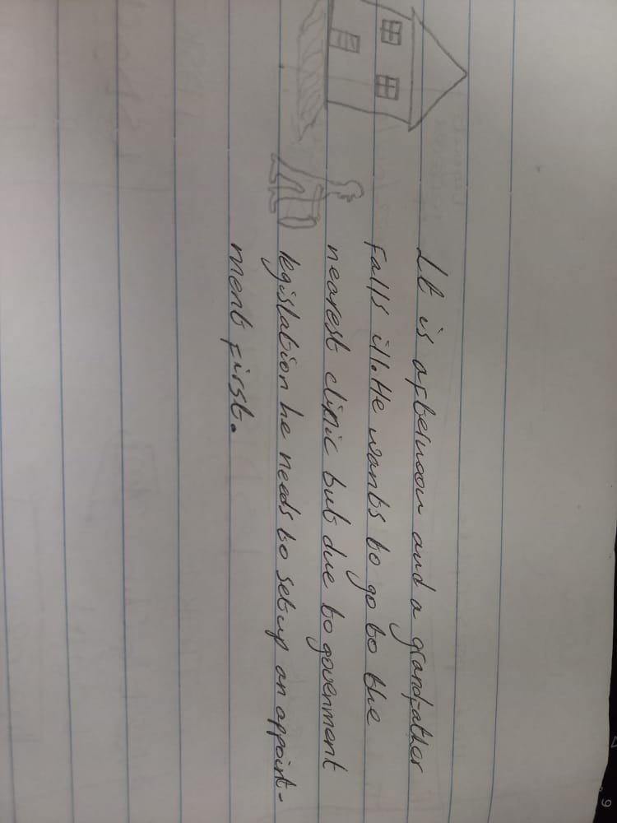
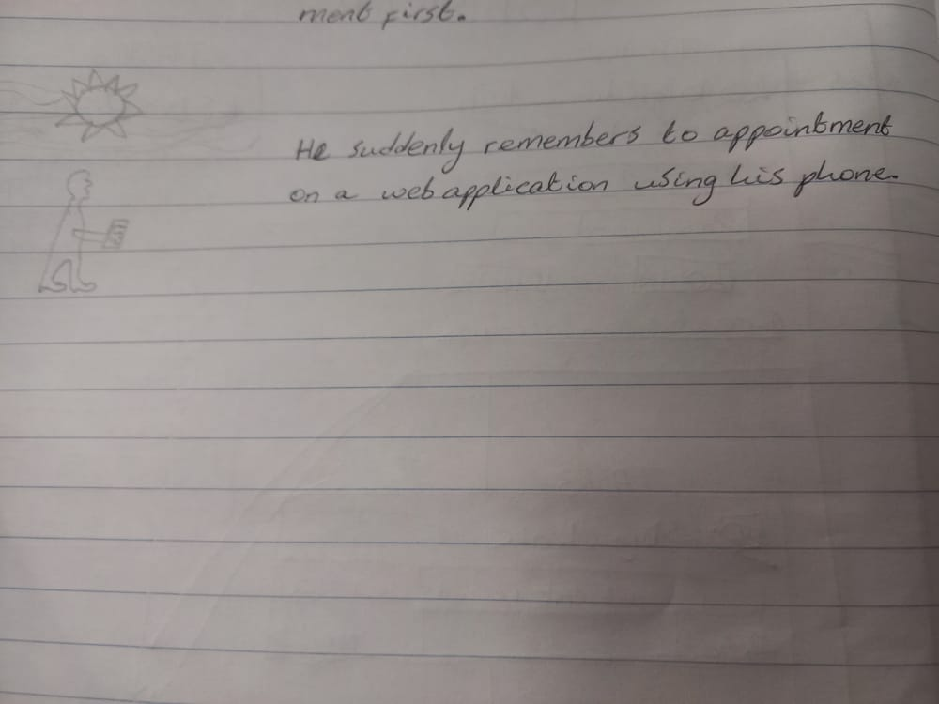
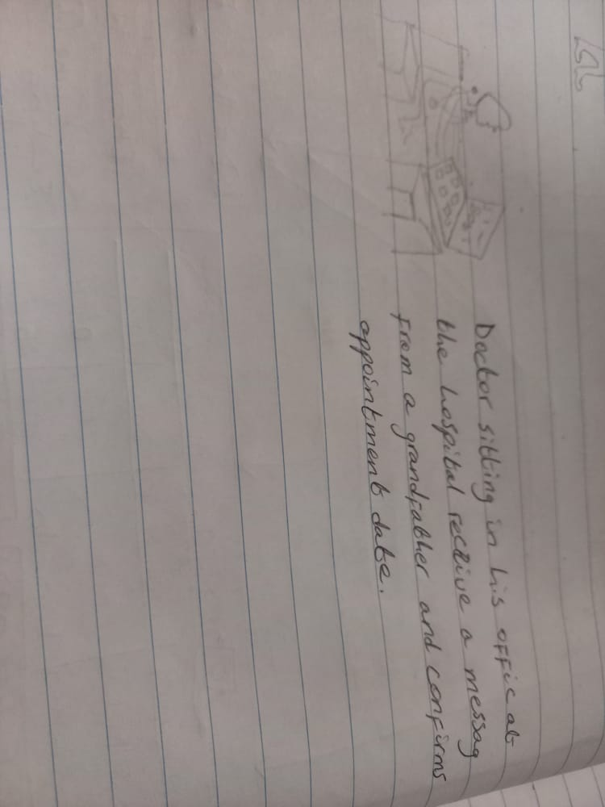
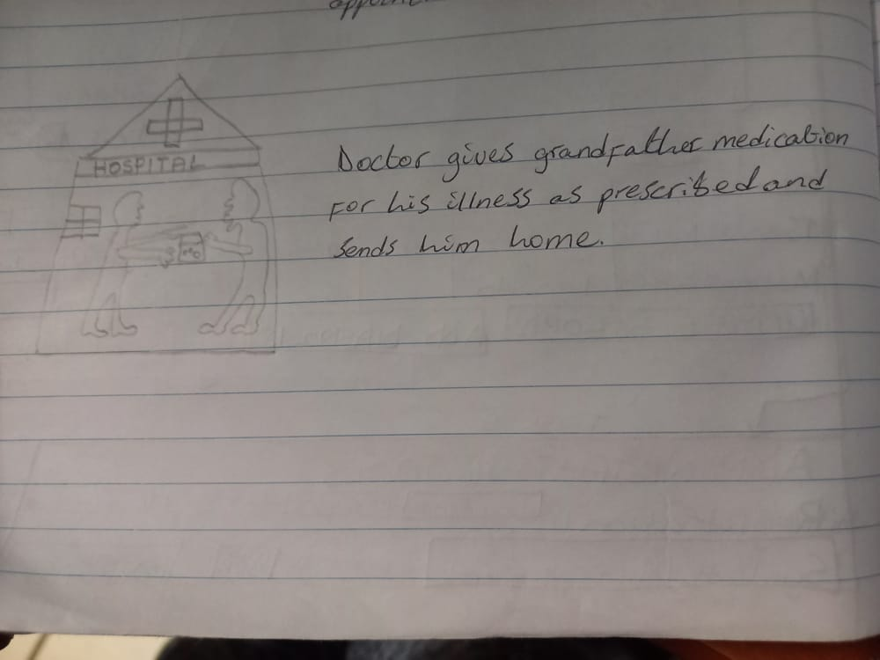
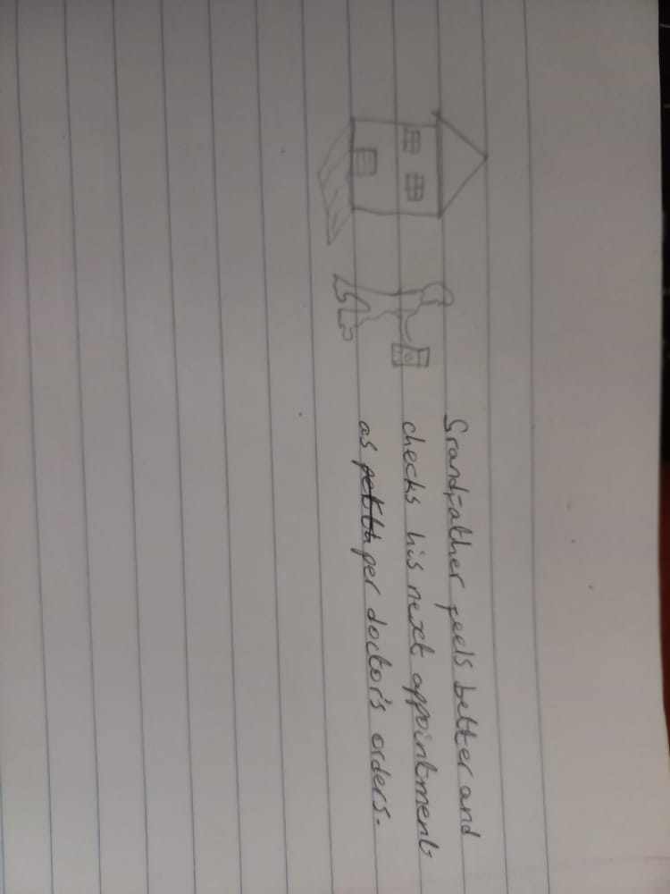

c) Card based prototype
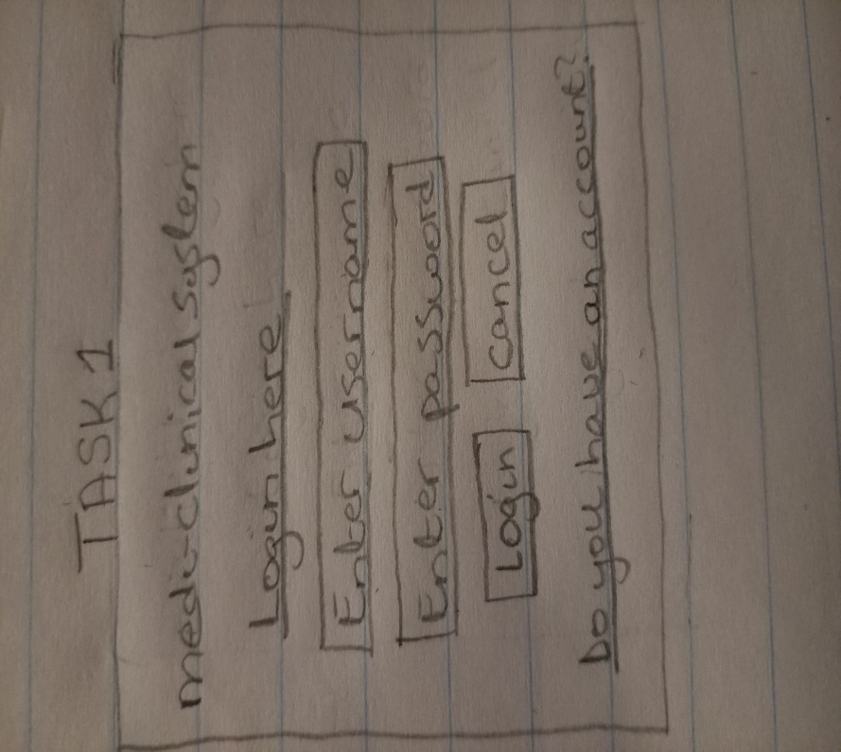
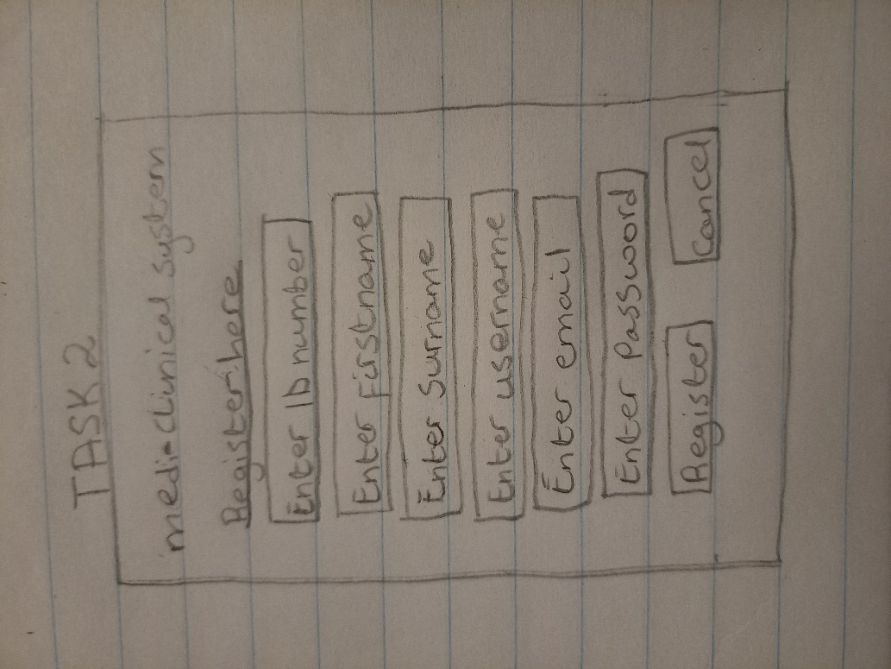
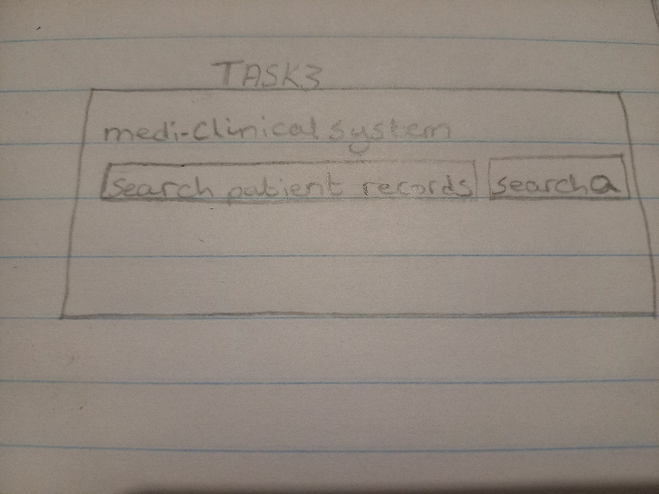
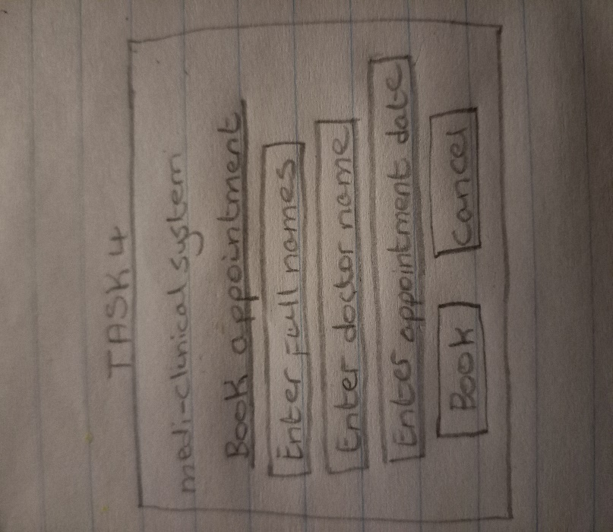
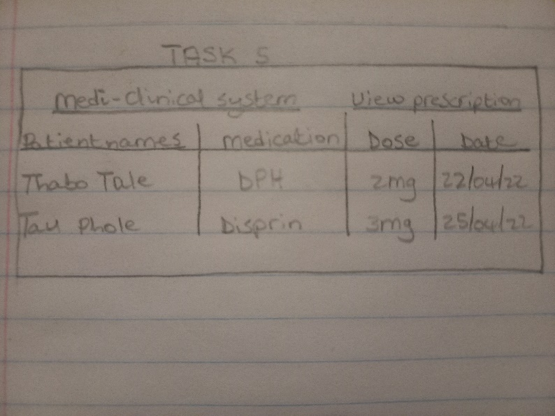
d) Single interface sketch of the system
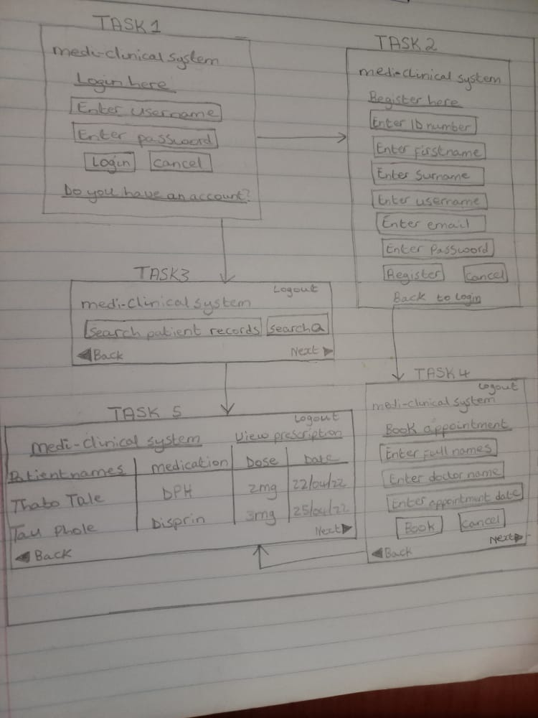
Justification of the answer based on prototype
- User experience: a user will be able to make good use of the system as very page is written to show the action performed in it, login page is clearly stipulated together with buttons. There will be no usability negativity as the language is clear and jargon not used.

Question 3
- Problems encountered by users
- No reset password option for one who forgot it.
- There is no language translator for on who cannot speak/understand English fully.
- No user manual for computer illiterates.
Question 3
- Activities done to conduct field study
Finding researchers
- According to Enago Academy (2022), the first part is to find the right candidate who are to conduct a research and mostly they should be skilled in the area.
Creating a research topic
- The appropriate topic to research on is defined by those involved based on the scenario at hand.

3. Identify the right method of research
Finding a suitable research method
- A suitable method for research is defined in detail so the correct objectives are achieved.
visiting the research site to gather information
- The researchers start observing the behaviour of users when in the field using the system, so they can come up with a conclusion based on whether the expected results are being achieved or not.
Analyse data acquired after research
- Task decomposition: according to www.tutorialspoint.com, decomposition of task means dividing it into small pieces breaking into smaller workable pieces. Each work done will be split in small pieces and divided into sub-tasks, so it can be analysed better.
- Protocol analysis: the users in the field will be observed and important issues noted.
Giving out results
- A report from the field study will be documented and detailed so it outlines all the outcome findings of the research.
Reference:
Qualitative data type will be collected after a thorough evaluation. According to Sharma (2020), this type of information does not include numbers and measurements but rather focuses on describing objects. The expected results should tell whether the users are able to register and login to medi-clinical system. They should further show if the nurses can search and view records in the system

Question 4
Interface sketch
Evaluation
- Pointer buttons are clearly marked: the system has next and back buttons to demonstrate for the user how to navigate to other pages.
- Consistency, standard and evaluation: the system is built such that it has the same structure throughout instead of creating a different one for each page.
- Minimizing of memory for users: the system is designed such that a user who registered does not register again as the system already can detect their credentials for login which saves storage space on database.
- User control and freedom: the user can erase information entered if they change their mind by clicking clear button, so they enter correct one which gives them freedom and control of the system.
- Visibility of system status: the system keeps the users informed of where they are since it shows the name of action to be performed in each page, for instance; login and registration page are specified.
- Help and documentation: the system does not have a manual which serves as a guide for users who are not familiar with the system.
- Matching system with real world: the system dos not contain jargon or technical words which allows users of all background to understand language used.

Reference list
Enago Academy (2022) How to Conduct Field Research Study? [ONLINE] Available at https://www.enago.com/academy/how-conduct-field-research-study-complete-guide/ (Accessed 14 April 2022).

Golodov, S. (2019) Custom SRS Document. [ONLINE] Available at https://www.belitsoft.com (Accessed 14 April 2022).

Neal, D. and Carroll, J (2020) The Role of Metaphor in User Interface Design. [ONLINE] Available at https://www.sciencedirect.com (Accessed 14 April 2022).

Sharma, R. (2020) Types of Data. [ONLINE] Available at https://www.upgrad.com/blog/types-of-data/ (Accessed 14 April 2022).

Wilson, M. (2017) 5 User Experience Goals to Set. [ONLINE] Available at https://ux.walkme.com/5-user-experience-goals-set/ (Accessed 14 April 2022).

www.tutorialspoint.com (2022) Design Process & Task Analysis [ONLINE] Available at https://www.tutorialspoint.com/human_computer_interface/design_process_and_task_analysis.htm (Accessed 14 April 2022).

